./

GENESIS – Advanced Python Report



|  |  |  |  |  |  |
| --- | --- | --- | --- | --- | --- |
| **Ver. Rel. No.** | **Release Date** | **Prepared. By** | **Reviewed By** | **To be Approved** | **Remarks/Revision Details** |
| 01 | 12-12-2020 | Sriram R M |  | Srinivas |  |
|  |  |  |  |  |  |
|  |  |  |  |  |  |
|  |  |  |  |  |  |
|  |  |  |  |  |  |

**Details**

Contents

Contents 3

MOVIE TICKET BOOKING MANAGEMENT SYSTEM 4

**Python Code without OOPS concept:** 4

**PEP8 Screenshot:** 6

**Python Code using OOPS Implementation:** 7

**PEP8 Screenshot**: 11

Figure 1 PEP8 for code without OOPS concept 6

Figure 2PEP8 for code with OOPS concept 11

# MOVIE TICKET BOOKING MANAGEMENT SYSTEM

## **Python Code without OOPS concept:**

movie_list = {"Superman": 250, "Avengers": 300, "Hulk": 200}

a = 1

def movie_add():

movie = input("Enter movie name")

while True:

try:

price = int(input("Enter price of the ticket"))

break

except:

print("Invalid input")

movie_list[movie] = price

print("Movie added successfully")

def movie_view():

print("Movies running now")

cnt = 1

for i in movie_list.keys():

print(cnt, "Movie Name-", i, "\tTicket Price-", movie_list[i])

cnt = cnt+1

print("\n")

def movie_search():

movie = input("Enter movie name\t")

if movie in movie_list.keys():

print(movie, "\navailable\n")

return 1

else:

print("\nMovie not available\n")

def movie_book():

movie = input("Enter movie name\t")

if movie in movie_list.keys():

total_ticket = int(input("Enter the number of tickets to be booked\t"))

price = movie_list[movie]

cost = (price*total_ticket)

print("Movie booked succesfully")

print("Amount to be paid: ", cost, "\n")

else:

print("\nMovie not available")

def menu():

while True:

print("Welcome to the home screen")

print("Enter 1 to view movies")

print("Enter 2 to search a mpvie")

print("Enter 3 to add a movie")

print("Enter 4 to book a movie")

while True:

try:

choice = int(input("Enter the choice"))

break

except:

print("Invalid input")

if(choice == 1):

movie_view()

elif(choice == 2):

movie_search()

elif(choice == 3):

movie_add()

else:

movie_book()

menu()

## **PEP8 Screenshot:**

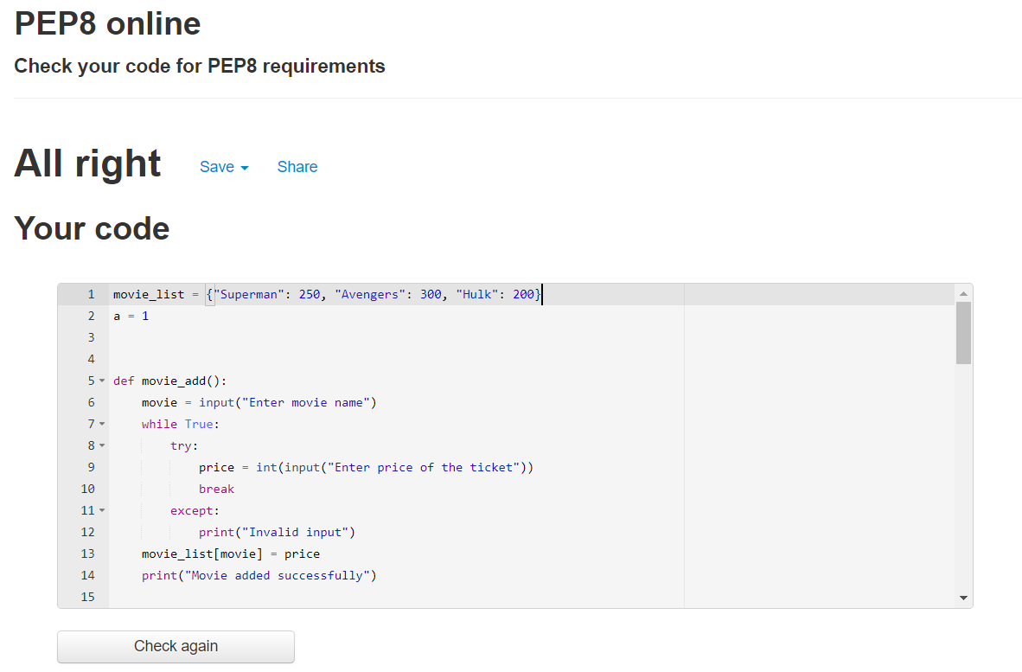

Figure PEP8 for code without OOPS concept

## **Python Code using OOPS Implementation:**

import requests # For making http requests

import re # For regular expressions

from bs4 import BeautifulSoup # For pulling data out of HTML files

movie_list = {"Superman": 250, "Avengers": 300, "Hulk": 200, "Ironman": 400}

adm_psw = "password"

class Movie: # Class movie for movie related functions

def __init__(self, name=0, price=0):

self.name = name

self.price = price

def movie_add(self):

finput = open("movies.txt", "r")

self.name = input("Enter the movie you want to add: ")

while True:

try:

self.price = int(input("Enter the ticket price: "))

break

except:

print("Invalid input")

if self.name not in finput.read():

finput.close()

fo = open("movies.txt", "a")

fo.write("\n"+self.name)

fo.close()

else:

print("\nMovie already exists")

def movie_view(self):

print("Movies running now")

cnt = 1

for i in movie_list.keys():

print(cnt, "\tMovie Name:", i, "\tPrice", movie_list[i])

cnt = cnt+1

def movie_search(self):

finp = open("movies.txt", "r")

if self.name in finp.read():

print(self.name, "is currently running\n")

finp.close()

return 1

else:

print("\nMovie not available\n")

class Customer(Movie): # Class customer inherits from class movie

adm_val = 0

def __init__(self, c_name=0):

self.c_name = c_name

self.ic = self.Rating()

@classmethod # This is a class method

def adm_set(cls):

cls.adm_val = 1

@classmethod # This is a class method

def adm_unset(cls):

cls.adm_val = 0

def book_movie(self):

movie = input("Choose the movie you wish to watch: ")

while True:

try:

total_ticket = int(input("Enter the total number of seats: "))

break

except:

print("Invalid input")

while True:

if(re.match(r'[2-9]', str(total_ticket))):

break

else:

print("Invalid number of seats")

while True:

try:

total_ticket = int(input("Re-enter: "))

break

except:

print("Invalid input")

if movie in movie_list.keys():

price = movie_list[movie]

cost = (price.__mul__(total_ticket)) # using magic method mul

if(Customer.adm_val == 1):

print("Congrats!!!You received admin discount")

self.c_name = input("Enter your name")

cost = cost.__sub__(100) # using magic method sub

print("Movie booked succesfully")

print("Amount to be paid: ", cost, "\n")

dat = open("info.txt", "a")

dat.write("Customer name: "+self.c_name+"\t")

dat.write("Movie booked: "+movie+"\t")

dat.write("Tickets booked: "+str(total_ticket)+"\t")

dat.write("Total cost: "+str(cost)+"\n")

dat.close()

else:

print("\nMovie not available")

class Rating: # Class rating is inside class customer

def get_rating(self):

print("To see the imdb rating")

print("Enter 1 for Superman")

print("Enter 2 for Avengers")

print("Enter 3 for Hulk")

print("Enter 4 for Ironman")

while True:

try:

opt = int(input())

break

except:

print("Invalid input")

if(opt == 1):

url_imdb = "https://www.imdb.com/title/tt0078346/"

elif(opt == 2):

url_imdb = "https://www.imdb.com/title/tt0848228/"

elif(opt == 3):

url_imdb = "https://www.imdb.com/title/tt0286716/"

elif(opt == 4):

url_imdb = "https://www.imdb.com/title/tt0371746/"

r = requests.get(url=url_imdb)

soup = BeautifulSoup(r.text, 'html.parser')

title = soup.find('title')

print(title.string)

ratingValue = soup.find("span", {"itemprop": "ratingValue"})

print(ratingValue.string)

class Admin(Customer): # Class admin inherits from Customer

@staticmethod # This is a static method

def log_in():

passwd = input("Enter the password for admin log-in")

if(passwd == adm_psw):

return 1

else:

return 0

def view_orders(self):

dat = open("info.txt", "r")

print(dat.read())

dat.close()

def menu(): # This acts as the home screen

while True:

print("Welcome to the home screen\n")

print("Enter 1 to add a movie")

print("Enter 2 to view all movies")

print("Enter 3 to search a movie")

print("Enter 4 to book tickets")

print("Enter 5 to view bookings")

print("Enter 6 to view movie ratings\n")

print("Enter any other keys to exit\n")

while True:

try:

choice = int(input())

break

except:

print("Invalid option")

if(choice == 1):

adm = Admin()

if(Admin.log_in()):

adm = Movie()

adm.movie_add()

else:

print("Wrong admin password")

elif(choice == 2):

mov = Movie()

mov.movie_view()

elif(choice == 3):

movie = input("Enter the movie you want to search: ")

mov = Movie(movie)

mov.movie_search()

elif(choice == 4):

print("Want to view movies as admin or customer")

opt = int(input(("Enter 1 for admin\nEnter 2 for customer")))

if(opt == 1):

adm = Admin()

if(Admin.log_in()):

Customer.adm_set()

adm.book_movie()

Customer.adm_unset()

elif(opt == 2):

person = input("Enter your name: ")

cus = Customer(person)

cus.book_movie()

elif(choice == 5):

adm = Admin()

Admin.log_in()

adm.view_orders()

elif(choice == 6):

cus = Customer()

i = cus.ic

i.get_rating()

else:

break

menu()

## **PEP8 Screenshot**:

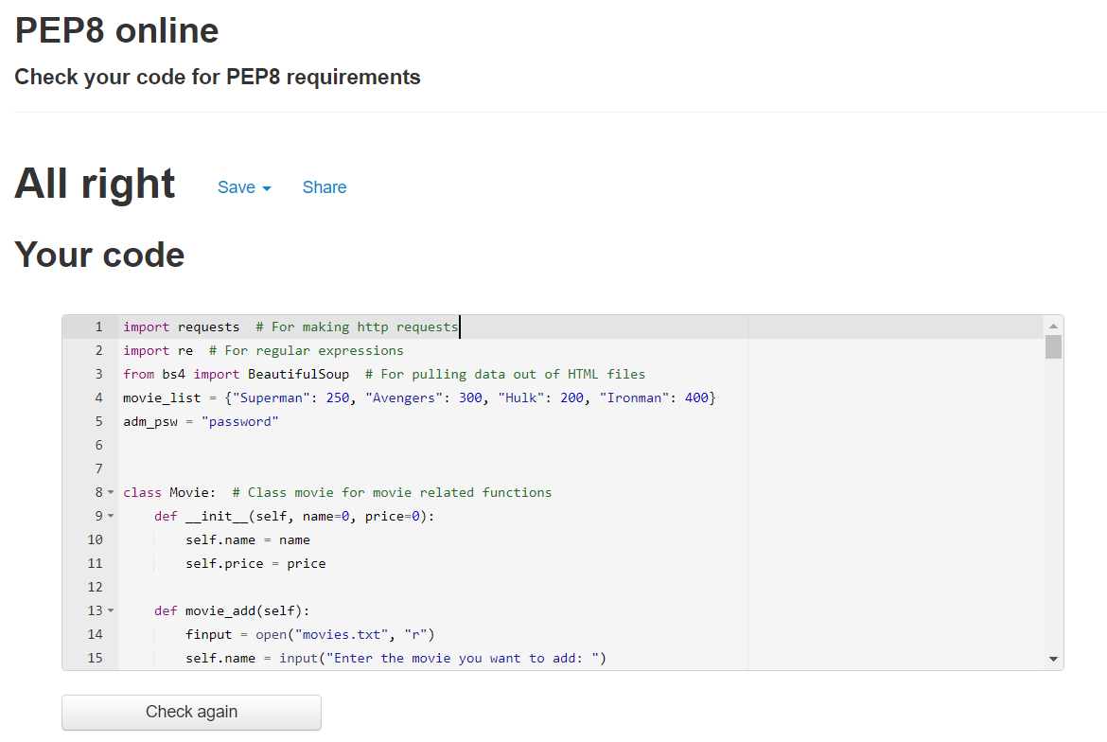

Figure PEP8 for code with OOPS concept